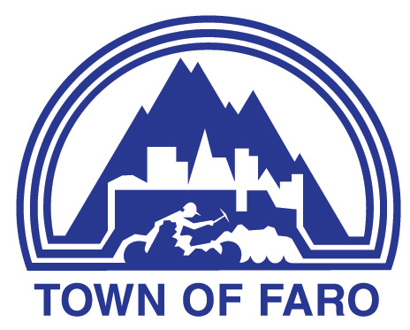
Agenda
Special Meeting
Public Hearing – Zoning Bylaw Update
February 26, 2026, at 6:00 p.m.
Council Chambers

- CALL TO ORDER

- ADOPTION OF AGENDA

  - Council Meeting Agenda

- NEW BUSINESS

  - Presentation by Elevator Yukon re: Draft Zoning Bylaw

  - Public Discussion / Questions re: Draft Zoning Bylaw

- ADJOURNMENT

RESOLVED THAT the February 26, 2026, Public Hearing – Zoning Bylaw be adjourned at ________ p.m.

