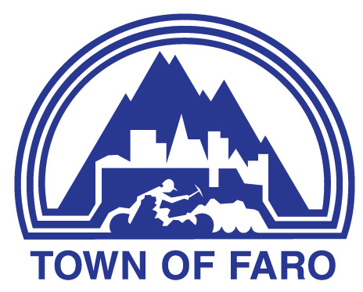
Agenda
Town of Faro Regular Council Meeting
March 3, 2026, at 7:00 p.m.
Council Chambers

- CALL TO ORDER

- ADOPTION OF AGENDA
  - Council Meeting Agenda

- DELEGATIONS & HEARINGS

- BUSINESS ARISING FROM DELEGATIONS & HEARINGS

- ADOPTION OF MINUTES
  - Minutes of the February 24, 2026, Regular Meeting of Council
  - Minutes of the February 26, 2026, Special Meeting of Council

- BUSINESS ARISING FROM MINUTES

- FINANCIAL
  - Finance Report

- REPORTS
  - Mayor’s Report
  - Council Reports
  - Administration’s Reports
    - Chief Administrative Officer
    - Manager of Operations
    - Manager of Recreation and Culture
  - Committee Meeting Minutes and Reports

- BYLAWS

- UNFINISHED BUSINESS
  - Draft Response letter re: Email from Minister of Northern and Arctic Affairs and Minister responsible for the Canadian Northern Economic Development Agency, to MLA Patti McLeod re: Local Economic Benefit from the Faro Mine Remediation Project
  - Road Naming - McCraken Road, Johnson Lake Road
  - Association of Yukon Communities (AYC) Resolutions

- NEW BUSINESS
  - Federation of Canadian Municipalities (FCM) Conference (June 4-7, 2026, Edmonton, AB)
  - Community Lotteries Program Policy
  - Municipal Vehicle Use Policy – Draft
  - Weight Room Passes for Medical Professionals

- CORRESPONDENCE FOR INFORMATION (OUT & IN)
  - Letter from the Canadian Northern Economic Development Agency, dated February 4, 2026, re: CanNor 2026 – 2027 EOI: Retained for possible future consideration – Town of Faro - Solar Complex Commercial Asbestos Remediation - Yukon Region
  - Email from the Tū Łī́dlini (Ross River) Protected Area Steering Committee, dated February 26, 2026 (and original letter from the Town of Faro).

- PUBLIC QUESTION PERIOD

- IN-CAMERA
  - Property Matter - in accordance with Municipal Act Section 213 (3)(e) re: Offer to Purchase
  - Conduct of Investigation - in accordance with Municipal Act Section 213 (3)(g) re: Code of Conduct Sanctions
  - Legal Matter - in accordance with Municipal Act Section 213 (3)(f) re: Legal Matter

- ADJOURNMENT

