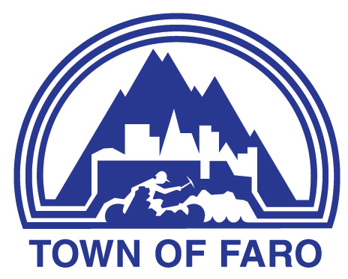
Agenda
Town of Faro Regular Council Meeting
June 2, 2026, at 7:00 p.m.
Council Chambers

- CALL TO ORDER

- ADOPTION OF AGENDA
  - Council Meeting Agenda

- DELEGATIONS & HEARINGS
  - Jordan Stackhouse and Graham White, Elevator Yukon re: Official Community Plan Amendments

- BUSINESS ARISING FROM DELEGATIONS & HEARINGS

- ADOPTION OF MINUTES
  - Minutes of the May 19, 2026, Special Meeting of Council

  - Minutes of the May 19, 2026, Regular Meeting of Council

- BUSINESS ARISING FROM MINUTES

- FINANCIAL
  - Finance Report

- REPORTS
  - Mayor’s Report
  - Council Reports
  - Administration’s Reports
    - Chief Administrative Officer
    - Manager of Operations
    - Manager of Recreation and Culture
  - Health and Safety Committee
    - Minutes of the April 14, 2026, Health & Safety Committee

- BYLAWS
  - 2026-04 – Noise Bylaw – First Reading

  - 2026-04 – Noise Bylaw – Second Reading

- UNFINISHED BUSINESS
  - Sale of Land Policy

  - Housing Accelerator Fund - Residential Conversion Grant Policy – Amendment

- NEW BUSINESS
  - Licence Agreement with Minister of National Defence (Rangers & Jr. Rangers)

- CORRESPONDENCE FOR INFORMATION (OUT & IN)
  - Letter from Department of Environment, dated May 14, 2026, re: Launch of Yukon Conservation Fund

- PUBLIC QUESTION PERIOD

Public Questions

- IN-CAMERA
  - Land Matter – in accordance with Municipal Act Section 213 (3)(e) re: Property Sales
  - Legal Matter - in accordance with Municipal Act Section 213 (3)(f) re: Legal Matter

- ADJOURNMENT

