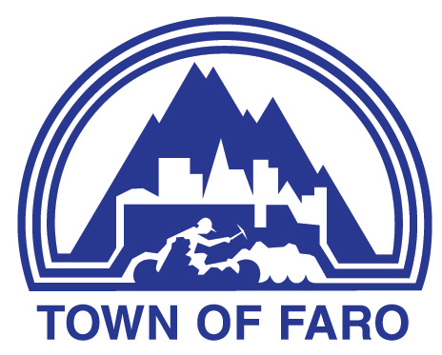
Agenda
Town of Faro Special Council Meeting
February 10, 2026, at 7:00 p.m.
Council Chambers

- CALL TO ORDER

- ADOPTION OF AGENDA

  - Council Meeting Agenda

Proposed Motion

RESOLVED THAT the agenda for the February 10, 2026, Special Meeting of Council be adopted as presented.

- NEW BUSINESS

Presentation by Parsons outlining their process for tendering.

Proposed Motion

- ADJOURNMENT

Proposed Motion

RESOLVED THAT the February 10, Special Meeting of Council be adjourned at ________ p.m.

