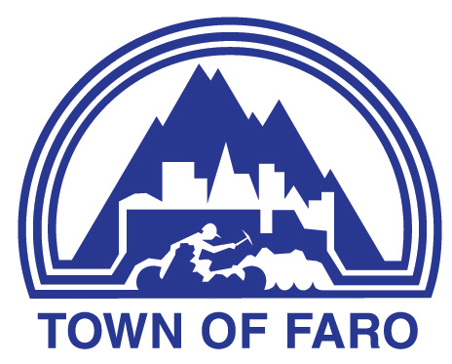
Agenda
Town of Faro Regular Council Meeting
April 21, 2026, at 7:00 p.m.
Council Chambers

- CALL TO ORDER

- ADOPTION OF AGENDA
  - Council Meeting Agenda

- DELEGATIONS & HEARINGS
  - Sgt Cedric Proulx, RCMP Ross River/Faro Detachment Commander

- BUSINESS ARISING FROM DELEGATIONS & HEARINGS

- ADOPTION OF MINUTES
  - Minutes of the April 7, 2026, Regular Meeting of Council
  - Minutes of the April 14, 2026, Special Meeting of Council

- BUSINESS ARISING FROM MINUTES

- FINANCIAL
  - Finance Report

- REPORTS
  - Mayor’s Report
  - Council Reports
  - Administration’s Reports
    - Chief Administrative Officer
    - Manager of Operations
    - Manager of Recreation and Culture
  - Health and Safety Committee
    - Minutes of the February 17, 2026, Health & Safety Committee
    - Minutes of the March 17, 2026, Health & Safety Committee

- BYLAWS

- UNFINISHED BUSINESS
  - Hiring Policy
  - Community Lottery Program Transfer Payment Agreement (2026/2027)
  - Seniors Carpet Bowling - Community Lottery Program Application

- NEW BUSINESS
  - Request from Del Van Gorder Graduation Class Landfill Clean-up Fundraiser
  - Faro Golf Club Request for Authorization for Liquor Use Permit
  - Faro Golf Club re: Support for Annual Golf Tournament
  - Proposed MOU Tintina Gun Club
  - Recreation Rules Policy – Draft
  - Weight Room Passes for Medical Professionals
  - Housing Accelerator Fund Application – Residential Conversion Grant

- CORRESPONDENCE FOR INFORMATION (OUT & IN)
  - Letter from Valerie Fromme, Returning Officer, Del Van Gorder School Council Election

- PUBLIC QUESTION PERIOD

- IN-CAMERA
  - Land Matter - in accordance with Municipal Act Section 213 (3)(e) re: Subdivision Application
  - Conduct of Investigations - in accordance with Municipal Act Section 213 (3)(g) re: Code of Conduct (C04, C05, C11)
  - Communications Matter in accordance with Municipal Act Section 213 (3)(e) re: Draft Communications

- ADJOURNMENT

